PROJECT PLAN DOCUMENT

Almaz Karabayev

Document Date......................................................................................................................3
Project Title............................................................................................................................3
Project Definition & Purpose..................................................................................................3
Team Members & Roles..........................................................................................................3
Software Development Methodology..........................................................................................................................3
Planned Project Activities.......................................................................................................3
Schedule.................................................................................................................................4
Cost Estimation.......................................................................................................................4
Risks & Mitigation Plan...........................................................................................................4
Constraints & Dependencies...................................................................................................4
Management Plans (Cost, Communication, Quality) .............................................................5

Document Date: 29 October 2025
Project Title: Smart Cybersecurity Monitoring System for Small Businesses

Project Definition & Purpose
Small businesses often lack the resources to maintain strong cybersecurity. This project aims to develop a lightweight monitoring platform that detects suspicious activities and alerts users in real time. The main goal is to provide an affordable, automated security layer that helps prevent data loss and improve awareness.
The project’s purpose is to enhance the security posture of small businesses by making cybersecurity monitoring simple, accessible, and efficient.

Team Members & Roles
Almaz Karabayev — Project Manager, Software Developer, Tester, and Documentation Author

Software Development Methodology
Agile (Iterative Development)
The project will follow an agile approach with short development iterations. Each iteration includes analysis, design, coding, and testing. This allows flexibility and continuous improvement as the system evolves.

Planned Project Activities

Schedule
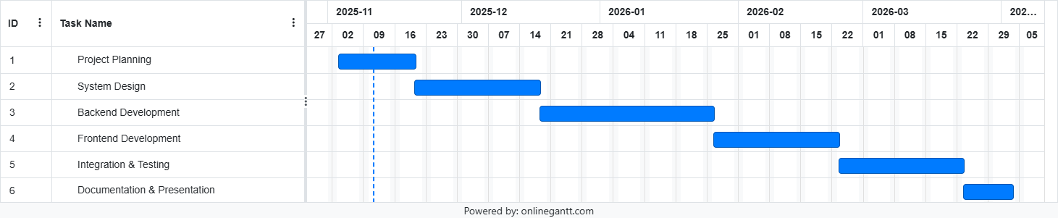
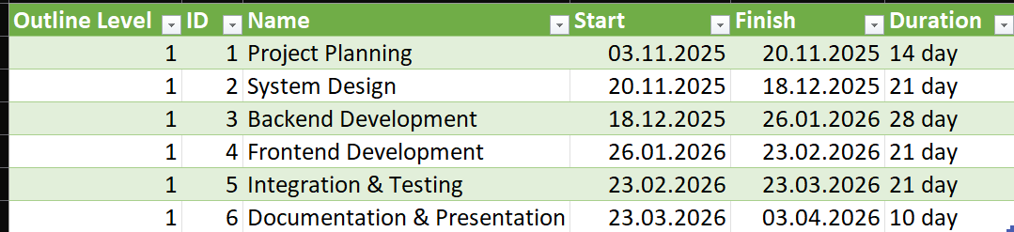

Network Diagram Summary:
1.0 → 2.0 → 3.0 → 4.0 → 5.0 → 6.0
Critical Path: 1.0 → 2.0 → 3.0 → 4.0 → 5.0 → 6.0 (Total duration ≈ 16.5 weeks)


Cost Estimation
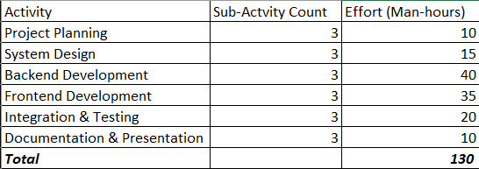
Risks & Mitigation Plan
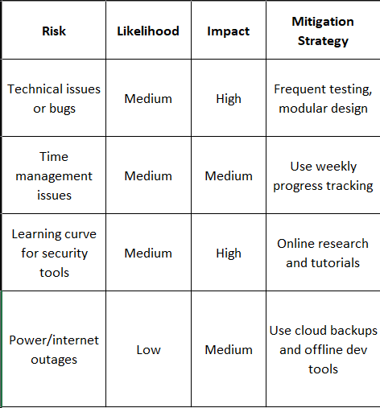

Constraints & Dependencies
Constraints:
- Limited personal time
- Fixed academic deadline
- Solo workload (no task delegation)
- Budget limitations
Dependencies:
- Cloud access (for database and deployment)
- Stable internet
- Functioning development tools (VS Code, GitHub, etc.)

Management Plans
Cost Management:
Track time and update cost sheet weekly to ensure effort stays within plan.
Communication Management:
Since it’s a solo project, communication happens mainly with the academic advisor (email/meetings).
Quality Management:
Code review by advisor or peer, regular tests after each module, and full documentation before submission.

